Agricultural development and environmental impacts in Latin America over the past 120 years
Alexander Urrego (Universidad de Barcelona)
Juan Infante-Amate (Universidad de Granada)
Eduardo Aguilera (Consejo Superior de Investigaciones Científicas)

Abstract
Latin American agriculture has experienced unprecedented growth since the late 19th century, generating environmental impacts that have accumulated over time and often remain in the shadows. The agricultural sector is directly linked to five of the nine planetary boundaries and is responsible for more than a third of global CO₂ emissions. In this context, Latin America stands out as one of the world’s leading producers of agricultural goods, while at the same time ranking among the regions that have historically contributed the most to climate change.
Discussions around agricultural development in Latin America have traditionally focused on its role during periods of integration into international markets (1870–30 and 1980 to the present) or its contributions during the era of inward-looking development strategies. In other words, emphasis has been placed on the relationship between agriculture and broader economic development models, while much less attention has been given to the specific growth strategies employed and their associated environmental impacts. We still lack estimates on how much agrarian expansion or agricultural intensification have contributed to growth in agricultural output. Even less is known about the environmental implications of these processes throughout the 20th century.
This chapter, therefore, aims to quantify the contribution of physical factors to agrarian growth, namely: extensification and intensification, and to assess the environmental impacts associated with them. To do that, we construct annual time series on land use, production, greenhouse gas emissions, deforestation, and disruptions in biogeochemical cycles (nitrogen and phosphorus use) for a representative sample of 20 countries in the region, analysed at both regional and subregional scales. These findings allow us to explore the lights and shadows of agrarian change in Latin America: on the one hand, its growing capacity to feed the population and generate surpluses for international markets; and on the other, the sector’s role in pushing the Earth system beyond its planetary boundaries.

- INTRODUCTION
The evolution of agriculture in Latin America has received considerable attention from the historiography due to its fundamental role in the region’s economic development. However, less attention has been paid to the environmental impacts of agricultural development. Over the past century and a half, agriculture has expanded across very different territories and become a decisive force in the regional economy. In 2021, Latin America produced more than half of the world’s soybeans (53%) and sugarcane (52%), and nearly one-fifth of its maize (18%) (FAOSTAT, ). Yet this success story has unfolded alongside deep social and ecological tensions, from food insecurity to mounting pressure on ecosystems.
In this chapter, therefore, we aim to analyse in parallel both the success story of agricultural expansion and the hidden costs of its environmental impacts. This study identifies the main phases and strategies of agrarian growth in Latin America between 1901 and 2020, drawing on long-term series of land use, agricultural production, and environmental impacts across twenty countries. The analysis seeks to answer two related questions: To what extent has agricultural growth in Latin America depended on land expansion and/or intensification? And what have been the environmental consequences of these strategies of growth in terms of deforestation, greenhouse gas emissions, and biogeochemical disruption?
The study of the historical environmental impacts of agriculture in Latin America is of particular interest for at least three reasons.
First, agriculture is today recognized as a major driver of global environmental change. Contrary to earlier assumptions that industrialization was the direct cause of ecological degradation, recent evidence shows that agriculture is a leading contributor to the transgression of the planetary boundaries such as nitrogen and phosphorus cycles, water use, biodiversity loss, and land-use change (Campbell et al, 2017; Infante-Amate et al, 2025). In this context, Latin America ranks among the highest contributors to global land-use change emissions, and in per capita terms, the region has even exceeded those reported in Western Europe since the Industrial Revolution (IPCC, 2023).
Second, the region’s exceptional biodiversity and vast carbon reserves make it particularly vulnerable to agricultural pressures. Latin America contains more than 20% of the world’s forest cover, more than one-third of global biomass carbon stocks, and is also a global biodiversity hotspot (Nash, 2022). Agricultural expansion in such settings generates disproportionately high ecological costs, as forests and ecosystems of global significance are converted into cropland or pasture.
Third, Latin America’s agricultural sector not only plays a central role in the global economy but also tells a long story of sustained growth, and, consequently, of sustained environmental impacts. The expansion of the agricultural frontier is related to deforestation and biodiversity loss, while intensification is associated to soil degradation, water contamination, and increasing dependence on external inputs. Between 1961-2020, cultivated land expanded by 152%, from 72 to over 180 million hectares, three times the global average. Nitrogen fertilizer use grew 24-fold (versus 9.5-fold globally), and the region now consumes about one-fifth of global pesticides despite accounting for only 9% of world nitrogen use (FAOSTAT, 2025).
Yet, although the environmental costs of current agriculture are increasingly documented, we still lack a long-term understanding of how agricultural output growth has shaped those outcomes, what Bulmer-Thomas described as development carried out “with scant respect for the environment” (Bulmer-Thomas, 2003: 9). In this vein, we identify three main bodies of literature on the relationship between agriculture and environment in the region.
On the one hand, research in ecological economics has quantified the environmental impacts of agriculture embedded in international trade as part of global processes, showing accelerated degradation since the 1990s, particularly through deforestation and land-use-change emissions (Hong et al, 2022; Kastner et al, 2014; Pendrill et al, 2019). A second avenue extends these approaches to long-term agroecosystem dynamics, examining nutrient balances, energy efficiency, and the socio-environmental consequences of agro-export models (Pengue & Rodríguez, 2017; Infante-Amate & Picado, 2018; Montero-Mora & Goebel-Mc Dermott, 2023; Urrego-Mesa et al., 2025). However, these studies generally focus on specific countries or crops and do not articulate a region-wide narrative.
On the other hand, Latin America and the Caribbean have cultivated a rich tradition of environmental history, often, though not exclusively, through the work associated with the Latin American and Caribbean Society for Environmental History (SOLCHA). Agricultural change and deforestation are recurrent themes in this field (Urquijo Torres et al., 2022), as seen in studies on Cuban forests and economic activity from the colonial period to the sugar boom (Funes Monzote, 2008) and in broader analyses of plantation economies and export-oriented rural change (Kaltmeier et al., 2024).
Yet, as Soluri and colleagues note, much of this literature remains nationally bounded, and a more integrated regional narrative is still emerging (Soluri et al., 2018). A promising transdisciplinary initiative in this regard is the ongoing work led by the Center for Advanced Latin American Studies (CALAS), which is producing a six-volume series on the Anthropocene from a Latin American perspective. Of special relevance for this chapter is the volume dedicated to land-use change, which explores the historical articulation between forest extraction and agriculture, including plantations, latifundia, and peasant systems, but does not provide a quantitative synthesis of agrarian growth and environmental indicators.
Despite the richness of this literature, there is still no long-term, region-wide study of agriculture’s environmental impacts that combines quantitative biophysical indicators with a historical narrative of transformation. This chapter addresses that gap by integrating economic history and ecological economics and by presenting a harmonized annual dataset for 20 countries to analyse the relationship between agricultural growth, land-use change, and environmental pressures in Latin America over the past 120 years.
- METHODOLOGY

2.1 Study Area
Although our analysis covers Latin America as a whole, the data are constructed from 20 of the 26 countries in the region. These countries represent 98% of total Latin America’s land area (20 million km²) and 98.5% of its population (652 million people) in 2020 (Table 5.A.1). According to land and population, those countries can be split in three main groups. First, Brazil, Argentina, and Mexico dominate, accounting for 65% of total land and 59% of population. Second, medium-sized countries such as Peru, Colombia, Bolivia, Venezuela, and Chile each contribute 3.8-6.4% of land and 3-7.8 % of population. And, third, smaller countries, mainly in Central America and the Caribbean, plus Paraguay, Ecuador, and Uruguay. These countries together represent 7.5% of the land and 17% of the population.
We use present-day national boundaries, since 20th-century border changes were minimal. Following independence (1804–1825), most territorial adjustments occurred in the 19th century, but only a few limited conflicts persisted afterward (Domínguez & Mares, 2003). For analytical clarity, we group countries into Central (Central America and Caribbean countries), Southern Cone (Argentina, Chile, Paraguay, Uruguay), and Andes (Peru, Colombia, Bolivia, Venezuela, Ecuador), while Mexico and Brazil are treated separately. The Latin American and Caribbean region (LACA) is made up of all these countries.
2.2 Agricultural Variables: Area and Production
We estimate physical production, cultivated area and yields of the agricultural and livestock subsectors at annual resolution (1901-2020), with the aim of capturing both regional and temporal patterns of productive change. The use of physical agricultural production data serves two main purposes. First, to identify growth strategies (extensification versus intensification) by decomposing the physical factors of output growth. Second, to link agricultural production and environmental impacts by estimating environmental intensity; that is, impacts per unit of output.
Data from 1961 onwards derive primarily from FAOSTAT (FAOSTAT, 2018). For 1946–1960, we use printed FAO Yearbooks. And, for 1901–1945 the series are reconstructed using International Institute of Agriculture (IIA) yearbooks. Given the scarcity of early data, the main innovation is that we complement international sources with national statistical yearbooks (see complete references in Table 5.A.3).
The complementarity between international and national sources yields good coverage. Using a conservative metric –the share of each period’s data in items with original observations, measured against the 1961 benchmark (Method A) – harvested area coverage averages 35% in 1901–1919, rising to 69% by the interwar period and 85% after 1940 (Table 5.A.4). For production, coverage rises from 32% to 68% to 79% over the same periods. These are conservative figures since the 1961 denominator includes products that were marginal or nonexistent in the early twentieth century (e.g., soybeans).
Coverage is highest in the Southern Cone (area: 77-94%) and Mexico (51-97%), while the Andean countries show lower but still meaningful coverage (5-43%). At the country level, the average pre-1961 area coverage exceeds 50% for 8 of 20 countries, and exceeds 25% for 14 of 20. Although the number of recorded items is smaller in the earliest decades, the available items tend to be the dominant crops: Mexico in 1901 records 14 items representing 81% of its 1961 output; Argentina records 4 crops in 1901, rising to 14 items by 1910 covering over 95% of 1961 area; Chile 7 items covering 44%.
We estimated missing values for production, yields, and, finally, used these two components to calculate missing area. Production was divided into domestic and export crops based on the export basket of the countries. We use trend-based extrapolation of population from the Maddison Project for domestic crops, while export crops followed the trends of the corresponding export crop series. When necessary, we used hierarchical aggregated trends by item-region, item-LACA, category-country, category-region, category-LACA or the trend of total LACA.
2.3 Environmental Impact Variables
Environmental impacts are inherently multidimensional, depending on which component of the environment is affected. Guided by the planetary boundaries’ framework (Richardson et al., 2003a), we focus on four core indicators: greenhouse gas emissions (GHG), deforestation, and biogeochemical flows of nitrogen (N) and phosphorus (P). These indicators capture the main pressures associated with agricultural expansion and intensification.
The series used are based on previous studies that we have unified, harmonized, and, in some cases, re-estimated to ensure consistency across countries and over time. Greenhouse gas emissions from fossil fuels and cement come from the Global Carbon Project (Andrew & Peters, 2021; Friedlingstein et al., 2022). Methane (CH₄), nitrous oxide (N₂O), and fluorinated gas emissions come from the PRIMAP-hist database (Gütschow et al., 2016). Emissions from land use, land-use change, and forestry are drawn from Jones et al. (2023), which are based on the average of three carbon-accounting models (Gasser et al., 2020; Hansis et al., 2015; Houghton & Nassikas, 2017). All emissions are expressed in carbon dioxide equivalents (CO₂-eq), using the 100-year global warming potential values reported by the IPCC (2021).
For analytical clarity, emissions are grouped into AFOLU (agriculture, forestry, and land use) and the rest, mostly related to fossil fuel use. AFOLU emissions include CO₂ from land-use change, N₂O from fertilizers, and CH₄ from livestock. Although uncertainty varies, especially for CH₄, N₂O, and CO₂ from LUC (IPCC, 2022; Minx et al., 2021), these datasets provide the most coherent long-term basis available.
Regarding deforestation, we use land-use cover data from the Land-Use Harmonization dataset—LUH2 (Hurtt et al., 2020). Based on this, we estimate annual net deforestation at the country level as the year-on-year change in total forest area, measured in hectares. For Latin America, the regional series is derived by summing the national net changes. This approach is focused on net rather than gross loss per pixel, which is consistent with national-scale analysis and enables the reconstruction of coherent historical trajectories. However, it may underestimate the magnitude of change in cases where forest gains (i.e., reforestation) offset gross losses, and it does not capture processes such as forest degradation or short-cycle logging and regrowth.
For nutrient-related impacts, we use the consumption of synthetic nitrogen and mined phosphorus fertilizers as a proxy for the human contribution to the disruption of these nutrient cycles, in line with planetary boundary studies (Steffen et al., 2015). These additional nutrients entering the biosphere can potentially generate multiple environmental and health impacts, including eutrophication and air and water pollution (Erisman et al., 2013; Guignard et al., 2017). For the period from 1961 onwards, the data come from FAOSTAT (2025). Before 1961, given the scarcity of specific historical data for Latin America, we apply global growth rates from Leigh (2004) to interpolate values back to 1947, thus maintaining consistency with the periodization scheme.
2.4 Formal Analysis
For the formal analysis of results, production series were converted into their energy content equivalent. The joule is used as the principal unit of measurement for production. To this end, agricultural output, originally recorded in metric tons, was transformed into its gross caloric value. This methodology avoids distortions caused by water content when mixing different types of outputs measured in physical weight and allows for a more meaningful analysis of land’s energy productivity at various levels of aggregation (Guzmán & González de Molina, 2017).
We apply a historical periodization based on structural breaks in agricultural output and harvested-area time series. Given the non-stationary nature of the series and the shifts in mean values over time, we estimate a linear trend model in which years are used as the time index (x). The optimal number of breakpoints is selected according to the Bayesian Information Criterion (BIC) and the Residual Sum of Squares (RSS). Finally, the periods are derived from the harvested-area time series, since this series allows a clearer distinction between the final phase of the First Globalization (1901–1919) and the subsequent period of crisis.
We complemented the descriptive analysis of the long trends by measuring the spatial concentration of agricultural production and decomposition of physical factors to growth. Geographic concentration was figured by a Herfindahl–Hirschman Index (HHI) for the top five crops (coffee, maize; soybean, sugarcane and wheat) in Latin America. For each year (t) and crop (i), we first computed the share of each country (c) in the regional total (pct). The HHI is then defined as the sum of squared country-crop shares:
$$HHI_{t,i}=\sum_{c=1}^{N}{{\left(pct_{c,t,i}\right)}^{2}}$$
The index ranges from 0 (maximum dispersion) to 1 (maximum concentration).
Decomposition of growth factors –quantifying extensification (E), intensification (I), crop specialization (ES), and regional specialization (ER) in the variation of agricultural production (PA)– follows the additive Logarithmic Mean Divisia Index (LMDI) method (Ang, 2005). Thus, changes in PA between year t-1 and year t can be decomposed as follows:

$$∆PA={PA}^{t}-{PA}^{t-1}=∆E+∆I+∆ES+∆ER$$

where E is the cultivated area for each crop analysed (i), measured in hectares. I corresponds to crop yield. ES is the share of each crop within the cropland of country (c). Finally, ER is the share of each country in total Latin American cropland. This formulation separates changes in crop composition within countries from shifts in the geographical distribution of agricultural land across countries. The formula for the decomposition of each factor is:

$$∆E=\sum_{i}{L\left(w_{i}^{t}-w_{i}^{t-1}\right)·\ln{(\frac{E_{i}^{t}}{E_{i}^{t-1}})}}$$
$$∆I=\sum_{i}{L\left(w_{i}^{t}-w_{i}^{t-1}\right)·\ln{(\frac{I_{i}^{t}}{I_{i}^{t-1}})}}$$
$$∆ES=\sum_{i}{L\left(w_{i}^{t}-w_{i}^{t-1}\right)·\ln{(\frac{{Es}_{i}^{t}}{{Es}_{i}^{t-1}})}}$$
$$∆ER=\sum_{i}{L\left(w_{i}^{t}-w_{i}^{t-1}\right)·\ln{(\frac{{ER}_{i}^{t}}{{ER}_{i}^{t-1}})}}$$
where w is:
$$w_{i}^{t}=\sum_{i}{\frac{{PA}_{i}^{t}-{PA}_{i}^{t-1}}{\ln\left({PA}_{i}^{t}\right)-\ln{{(PA}_{i}^{t-1})}}}$$

- THE GROWTH OF AGRICULTURE
This section examines the long-term evolution of agricultural growth in Latin America during the 20th century, tracking changes in area, output, and land productivity across both crop and livestock sectors. Figure 5.1 summarizes these dynamics and the structural breakpoints for harvested area (1919, 1946, 1981, and 1999) and agricultural output (1951, 1976, and 2000). For consistency with trade cycles and the historical literature, we adopt five periods based on harvested area, which better capture transitions between phases of expansion and contraction in the First Globalization.
The first period corresponds to the integration of Latin American agriculture into international markets (1901–1919), followed by the response to the crisis of the export model (1920–1946) (Pinilla & Aparicio, 2015). During the third period (1947–1981), agriculture became more closely tied to state-led industrialization strategies. The external debt crisis of 1982 marks the beginning of the fourth period (1982–1999), characterized by a renewed orientation toward international markets (Bértola & Ocampo, 2012). This shift accelerated in the early 21st century (2000–2020), driven by China’s rise as a major actor in global trade (Infante-Amate et al., 2022).
3.1 Long-Term Patterns of Growth and Specialization
Agricultural production in Latin America displays a clear dynamism throughout the 20th century. As shown in Figure 5.1, Panel A, total production increased by a factor of 26 between 1901 and 2020, from 0.54 petajoules (PJ) to 14 PJ, while cultivated area grew by a factor of 6, from 28 million hectares (Mha) to 172 Mha. This gap reflects the growing role of yield improvements and technological change. Up to mid-century, output and area evolved together, consistent with the logic of extensive-traditional agricultural systems, but after World War II output rose faster than area, indicating rising land productivity and the onset of intensification. Livestock followed a similar path with a delay: its take-off began in the 1960s, when productivity improvements decoupled output from pasture expansion (Figure 5.1 Panel B and C).
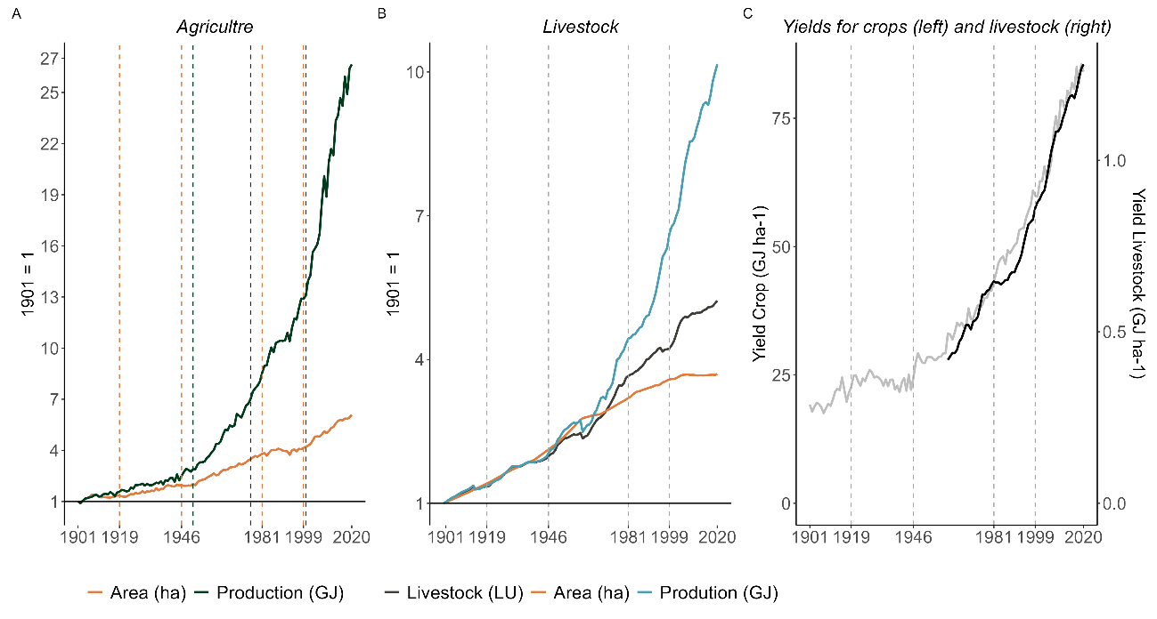
Figure 5.1: Agricultural growth in the long 20th century in Latin America.
Note: Index numbers for agriculture (A) and livestock (B) with base year 1901 = 1, and land yields in GJ ha⁻¹ (C). Broken lines indicate structural breaks. Source: our own data; see Section 2 for details.
Crop composition reveals continuities, changes, and defining features of Latin America’s agrarian system. Sugarcane has remained dominant, accounting for roughly half of total output throughout the century (Figure 5.2 Panel A). This regularity also holds for maize and wheat, which together represented about one-fifth of total output, or about one-quarter if all cereals are included. The composition of cultivated area, however, changes more markedly. Maize and wheat, which once occupied half of total cropland, fell to about one-third, largely replaced by soybeans. Introduced in the 1970s, soybean now covers roughly 35% of all cultivated area (Figure 5.2 Panel B).
A key feature, therefore, is the concentration of both production and area in few crops. The region’s history of agricultural growth can largely be told through five crops. Four traditional crops: maize, wheat, coffee, and sugarcane, along with the more recent soybean, have accounted for roughly three-quarters of total production and between 50% and 70% of cultivated area. Geographically, production and area were concentrated in Argentina and Brazil during the first half of the century (50–60%), rising to around 70% percent by the 1970s-80s. Nonetheless, countries such as Colombia, Cuba, and Mexico continued to play leading roles in coffee, sugarcane, and maize, respectively, highlighting the coexistence of large-scale agro-export economies with diverse national specializations.
The spatial distribution of these top five crops illustrates two main trends. Coffee and, to a lesser extent, wheat became more geographically diversified, while sugarcane and soybean grew increasingly concentrated. Maize maintained a relatively stable and widespread distribution. Coffee’s area shares in Brazil fell steadily from about 60% to 40% between 1901 and 1980, as Central America, Colombia, and Mexico expanded their participation. The Herfindahl–Hirschman Index (see Figure 5.A.1) for coffee declined from roughly 0.5 during the export-led phase to 0.2 by the end of the ISI period, a level that remained stable thereafter. Wheat followed a similar pattern: Argentina’s share fell from 82% in 1915 to 50% by 1980, while Brazil and Mexico expanded their area from 0.9 to 3.8 million hectares between 1947 and 1982.

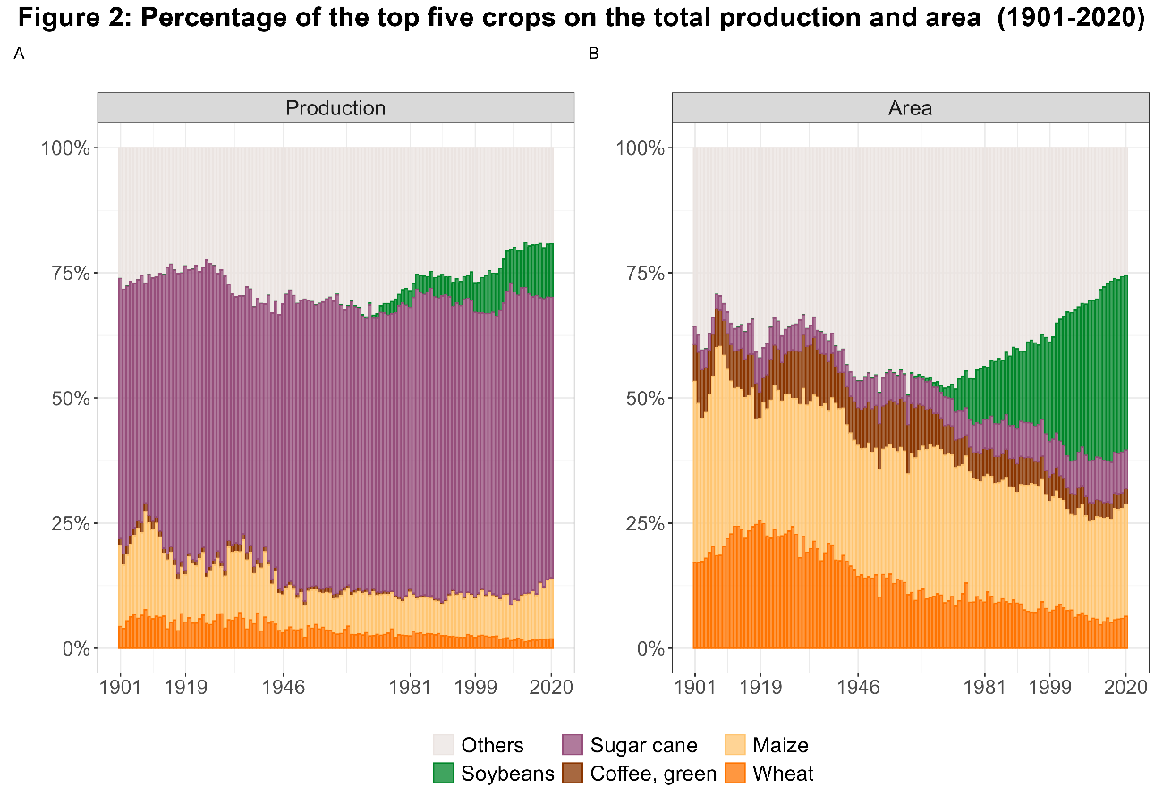
Figure 5.2: Percentage of the top five crops on the total production and area (1901-2020)
Source: our own data, see section 2 for details.
In contrast, sugarcane and soybeans reveal clear tendency toward concentration. Sugarcane, distributed among Brazil, Cuba, and other Caribbean producers at the beginning of the 20th century (HHI ≈ 0.2), became overwhelmingly Brazilian after the 1970s and by 2020, Brazil held about 70% of Latin America’s sugarcane area (HHI ≈ 0.6). Soybean cultivation expanded rapidly in Brazil from 0.35 Mha in 1964 to 8.2 Mha in 1982, concentrating up to 80% of the regional total. Argentina’s subsequent expansion in the late 1970s and 1980s, together with later growth in Paraguay, Bolivia, and Uruguay, reduced this concentration but reinforced soybean’s role as the emblem of a new regional specialization.
In a nutshell, agricultural growth in Latin America has combined remarkable increases in productivity after mid-20th century with growing concentration by crop and territory. To better understand these long-term trends, we now turn to a closer analysis of the strategies of extensification and intensification across different historical periods and regions.
3.2 From Land Expansion to Input Intensification (1901-2020)
During the first half of the 20th century, agricultural growth in Latin America was driven primarily by frontier expansion. Cultivated area and production increased in parallel (Figure 5.1 Panel A), reflecting a strong coupling between land and output typical of traditional systems (Federico, 2010 ). The export boom (1850–1913), then, was a land-intensive process; however, no Latin American country experienced land scarcity. The Southern Cone, especially Argentina, led this process, with annual growth in harvested area exceeding 4.8%, above the regional average of 4.3%, while Cuba also expanded rapidly (4.2%). This was not the case in Mexico, where the devastation caused by the Revolution helps to explain the contraction in cultivated area and the lack of data (Table 5.1).
These trends reflected the region’s specialization in land-demanding export crops such as wheat and maize in Argentina or coffee, cacao, tobacco, banana, and sugarcane in Central America and the Caribbean. Abundant land and limited labour favoured expansion over intensification. As Bulmer-Thomas (2003) observed, Latin America became known for its low land-to-man ratios. Thus, growth came from “opening” new areas rather than raising yields.
Table 5.1: Annual growth rates of area harvested and production by period and region
 | Region | 1st Gl. (1901-19) | Crisis (1920-46) | ISI (1947-81) | Crisis (1982-99) | 2nd Gl. (2000-20)
Area | LACA | 2.0% | 1.6% | 2.0% | 0.4% | 1.9%
 | Andean | - | 2.2% | 1.6% | 1.2% | 0.8%
 | Brazil | 1.7% | 2.2% | 3.2% | -0.2% | 2.5%
 | Central | 1.9% | 1.2% | 1.1% | 0.4% | 0.3%
 | Mexico | -1.6% | 0.7% | 2.7% | 1.0% | 0.1%
 | Southern | 4.3% | 1.5% | 0.5% | 1.1% | 2.3%
Production | LACA | 2.6% | 1.5% | 3.4% | 2.2% | 3.6%
 | Andean | - | 2.6% | 3.5% | 2.4% | 1.7%
 | Brazil | 0.5% | 2.4% | 4.4% | 2.9% | 4.7%
 | Central | 5.5% | 1.0% | 1.7% | -1.1% | 1.1%
 | Mexico | -0.6% | 2.9% | 5.1% | 1.6% | 1.4%
 | Southern | 3.9% | 0.4% | 2.3% | 2.5% | 3.6%
Source: our own data; see Section 2 for details.
After the Second World War, the region entered a new stage of state-led industrialization that also reshaped agriculture. Output and area recovered from the period of crisis (1920–1946) and continued to grow, but at different speeds: cropland increased by roughly 2% annually, while production rose by 3.4%, signalling rising land productivity (Table 5.1). The decoupling was driven by technological innovation and the spread of intensification strategies, though extensive practices persisted, particularly in frontier areas.
Livestock followed a slightly later trajectory. Until 1960, as shown by the Figure 5.1 Panel B, output growth stemmed mainly from the growing number of animals and the expansion of pastureland; afterwards, rising livestock density (from 0.53 to 0.67 LU ha⁻¹ between 1960 and 1980) and improved feeding systems became central. Although pasture area continued to grow, it did so at a slower pace, with annual rates of 1.2% between 1947 and 1981, except in Brazil, where pastureland grew even faster than production, 2.8% versus 2.6% (see Table 5.2).
Between 1947 and 1981, land yields increased 1.6-fold in crops and 1.4-fold in livestock, marking a turning point away from the extensive strategies that had dominated the first half of the 20th century (this result is consistent with Martín-Retortillo et al., 2026). Eventually, this combination of frontier expansion and technological innovation in the agricultural sector during the state-led development “[…] generated in many cases an important environmental degradation which was not faced by government policies […]” (Cárdenas et al., 2000: 20).
This dynamism challenges the narrative of agricultural stagnation and its alleged role as a factor of inflationary pressures under ISI (Bulmer-Thomas, ). At the aggregate level, the story of failure does not align with our findings, at least not when compared with earlier periods. However, a subregional perspective introduces important nuances. Countries that had already achieved high export growth, such as Cuba, Argentina, or Uruguay (Bulmer-Thomas, 2003), slowed down, while Brazil, Mexico, and the Andean countries accelerated (Table 5.1), as highlighted by previous studies (Cárdenas et al., 2000).

Table5.2: Annual growth rates of pasture, livestock units, and livestock production by period and region
Element | Region | 1st Gl. (1901-19) | Crisis (1920-46) | ISI (1947-81) | Crisis (1982-99) | 2nd Gl. (2000-20)
Pastureland (ha) | LACA | 2.0% | 1.5% | 1.2% | 0.6% | 0.1%
 | Andean | 1.5% | 1.0% | 1.2% | 0.3% | 0.0%
 | Brazil | 2.7% | 1.6% | 2.8% | 1.4% | 0.2%
 | Central | 1.2% | 2.7% | 1.7% | 0.4% | -0.1%
 | Mexico | 0.1% | 2.1% | 0.7% | 0.2% | -0.0%
 | Southern | 2.7% | 1.5% | 0.2% | 0.2% | 0.3%
Livestock (LU) | LACA | 1.6% | 1.4% | 1.8% | 0.8% | 1.0%
 | Andean | 1.8% | 2.4% | 1.7% | 0.9% | 0.8%
 | Brazil | 1.7% | 1.1% | 2.6% | 1.5% | 1.2%
 | Central | 3.3% | 0.9% | 1.7% | 0.3% | 1.4%
 | Mexico | 0.1% | 5.9% | 2.3% | 0.2% | 0.8%
 | Southern | 1.4% | 0.7% | 0.6% | -0.2% | 0.5%
Production (GJ) | LACA | 1.6% | 1.5% | 2.2% | 2.4% | 2.0%
 | Andean | 1.9% | 2.7% | 2.3% | 1.5% | 1.6%
 | Brazil | 1.6% | 1.3% | 2.6% | 4.0% | 2.6%
 | Central | 2.9% | 1.0% | 2.7% | 1.3% | 2.1%
 | Mexico | 0.1% | 5.7% | 3.6% | 0.6% | 1.9%
 | Southern | 1.6% | 0.8% | 1.1% | 1.8% | 1.3%
Source: our own data; see Section 2 for details.
From the 1960s onward, medium- and large-sized economies adopted mixed models that combined import substitution with incentives for agricultural exports (Bértola & Ocampo, 2012). In cases such as Colombia, agriculture assumed a triple role: feeding a growing population, supplying raw materials to industry, and generating foreign exchange to import capital goods (Cárdenas et al., 2000). State policies promoted both modernization –import facilitation for machinery and fertilizers, experimental stations, infrastructure, and credit (Bértola & Ocampo, 2012)– while also boosting colonization of public lands in frontier areas.
The ISI period, therefore, marked a dual process of continuing territorial expansion alongside a first wave of technological intensification, which helps us to understand the growing share of basic grains together with export crops such as wheat and coffee in Central America, the Andes, and Mexico, or wheat and sugarcane in Brazil. By the late 1970s, things began to change.
During 1982–1999, production grew at around 2% per year, slower than in the previous period, while cultivated land expanded by only 0.4% annually, a pattern that also characterized the livestock sector (see Tables 5.1 and 5.2). This pattern reveals that intensification, rather than expansion, became the main engine of output. Crop yields increased by 68% and livestock yields by 33% over the period. Livestock productivity improved particularly through the rapid growth of poultry, which had already begun to take off, albeit timidly, during the previous period (Bértola & Ocampo, 2012), and through the increasing use of imported feed.
The predominance of intensification after the mid-1980s shows that the diffusion of Green Revolution technologies –fertilizers, pesticides, improved seeds, and feed– occurred later and more gradually than often assumed. Instead of being a hallmark of the ISI phase, these innovations consolidated after liberalization, when external constraints favoured export-oriented, input-dependent production. Thus, two waves of intensification can be distinguished: the first associated with state-led modernization (1947-81), and the second driven by market forces (from the mid-1980s onward).
Commodity prices and foreign investment restrictions came to an end after more than two decades, stimulating both intensification and a partial return to land expansion. The early 21st century commodity boom, thus, represented not a break but an acceleration of earlier trends. In Brazil and the Southern Cone, expansion and capital-intensive production advanced together, while the Andes, Central America, and Mexico relied more on intensification. The region’s traditional land abundance now persisted only in Argentina and Brazil; elsewhere, cropland growth had largely exhausted available frontiers (Table 5.1). In land-constrained countries, openness promoted high-input, high-yield strategies. This divergence reflects not only environmental constraints but also the differential capacity of states and agribusinesses to respond to global market signals, attract capital, and implement new technologies.
In sum, between 1901 and 2020 Latin American agriculture evolved from a land-expansive to a capital- and input-intensive system. Expansion, modernization, liberalization, and globalization were successive responses to changing constraints and opportunities, yet each phase deepened specialization and reinforced different ecological pressures. This long trajectory sets the stage for analysing, in the next section, how different physical factors –area, yields, and specialization– contributed quantitatively to the growth of agricultural output.
3.3 Physical Factors of Growth
Figure 5.3 presents the variation in agrarian output across historical periods, showing extensive and intensive strategies in absolute terms (left panels) and as a share of total variation (right panels). It also allows comparison between the entire agricultural system, including livestock (top), and crop production alone (bottom). The left-hand plots (Figures 5.3 Panel A and C) show total variation in output for each period (black diamonds), while the coloured bars represent the contributions of different physical drivers. In addition to land expansion, production growth may also arise from three mechanisms associated with intensification: increases in yields, changes in the spatial distribution of cropland across countries, and changes in the composition of crops cultivated.
Yield improvements, captured by increases in output per hectare, are used as a proxy for technological change. Regional specialization is measured as the share of each country’s cropland in total Latin American cropland and reflects shifts in the spatial distribution of cultivated area across countries. Product specialization refers to changes in the composition of cropland across different crops. While the latter two components do not measure productivity directly, they capture structural shifts in the allocation of land across regions and crops, which may affect aggregate production when cropland expands toward crops and places with higher or lower average yields (see Section 2.4 for details).
In absolute terms, agrarian output increased sharply during both the ISI phase and the commodity boom, surpassing all previous levels. The only interruption in this long-term growth trajectory occurred during the debt crisis and economic liberalization of the 1980s and 1990s. Growth during both the ISI and commodity boom periods was driven by a combination of area expansion and intensification. For crops, yield improvements were central, while in the livestock sector intensification was largely due to product specialization, particularly the expansion of semi-industrial poultry systems during the ISI.
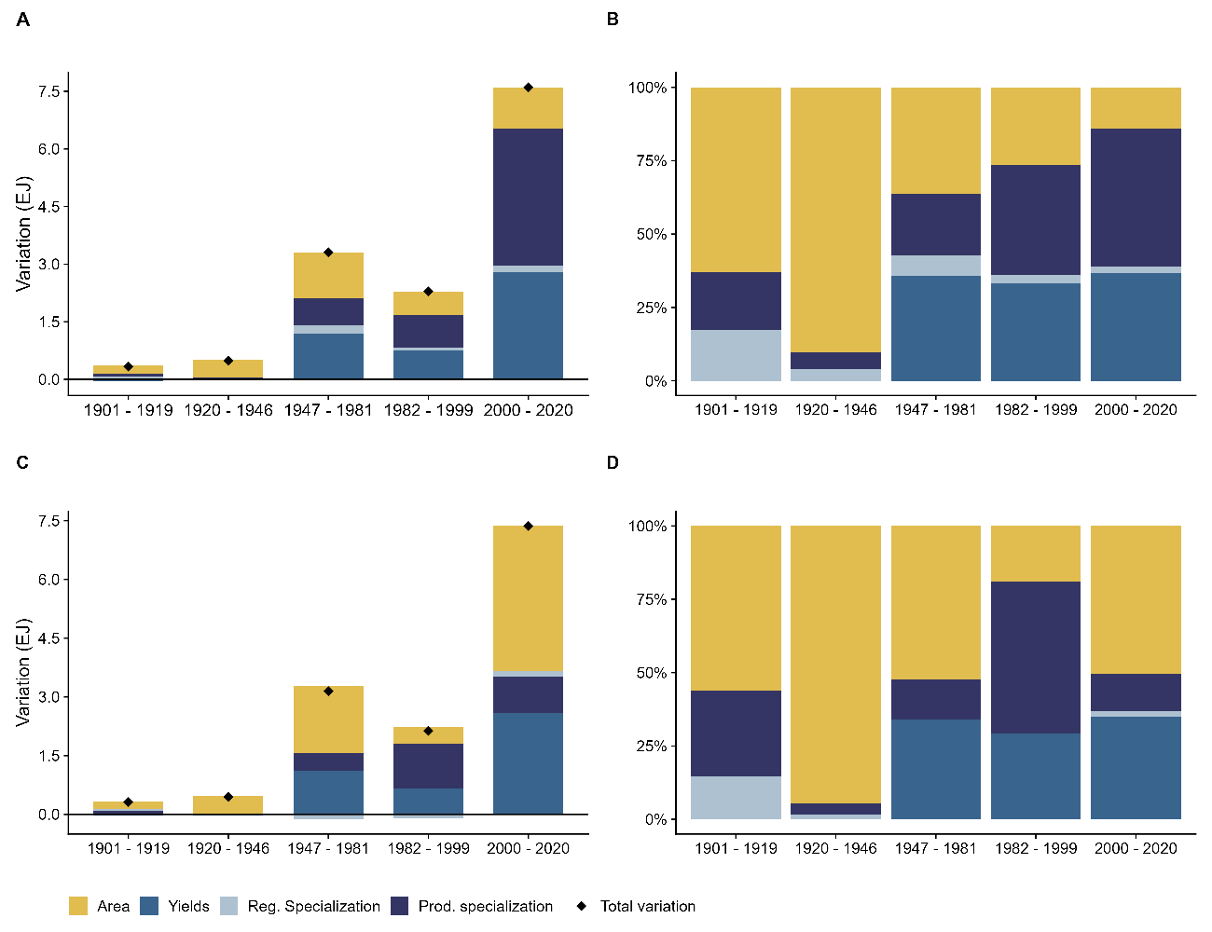
Figure 5.3: From Extensification to Intensification: The Physical Factors Behind the Growth of Latin American Agriculture
Note: Bars show absolute (left) and proportional (right) contributions of physical factors to the increase in agricultural output during each period. The intensive strategy includes yields, as well as regional and product specialization, while expansive refers to area increases. Panels A and B include the livestock sector, while C and D correspond only to crops. Source: our own data; see Section 2.4 for details.
Figures 5.3Panel B and D show that the relative contribution of intensification increased over time, rising from less than one-third during the early export-oriented expansion to more than 85% in the most recent period –except for the Great Depression, which was marked by purely extensive growth. However, the strategies of intensification differed between the first and second waves of globalization. During the first, intensification was primarily driven by regional and product specialization in crops, especially high-yield export products such as sugarcane and bananas in Central America and Cuba. In contrast, the second wave was more strongly associated with rising yields and increased specialization in livestock, reflecting a more technology-intensive growth pattern.
During the ISI, technological upgrading played a major role. Yield improvements–especially in Mexico, the Andean countries, and Central America–accounted for more than half of total output growth. When comparing the entire agricultural system with crop production alone, it becomes clear that intensification was more pronounced in the livestock sector, while crops remained more reliant on land expansion. This divergence is particularly evident during the ISI and the commodity boom.
The weight of intensification continued to grow after the debt crisis, particularly in crop production, where product specialization and yield improvements became the dominant growth strategies. This shift reflects both the diffusion of Green Revolution technologies and a renewed orientation toward agro-export specialization. While this trend was seen across most of the region, it was less marked in Central America. In the most recent period, a partial return to land expansion is observed, resulting in a mixed strategy of extensive and intensive growth in crop production in the Southern Cone and Brazil. At the same time, livestock intensification continued; this time fuelled by increasing specialization and the growing use of imported feed, reinforcing the region’s structural transformation and its embedded environmental impacts.
- THE ENVIRONMENTAL COSTS OF AGRARIAN SUCCESS
The productive success described above carried environmental costs that threaten the sustainability of the growth models. Here, we focus on four impacts linked to extensification and intensification.
4.1 Drivers of Agrarian Emissions: From Deforestation to Intensification
Figure 5.4 Panel A shows the historical trends of the four indicators analysed (indexed to 1946 = 1): agricultural emissions, deforestation, and nitrogen (N) and phosphorus (P) fertilizer use, providing a basis to assess their relative contribution to agrarian environmental change. All four indicators increased substantially over time, although those associated with expansion grew less than those linked to intensification.
Since 1946 N and P use rose by 72- and 78-fold, respectively, while deforestation and land-based emissions increased by factors of three and four along the whole century. This striking contrast reflects the different nature of these drivers. Fertilizer application can expand relatively freely, whereas deforestation and most land-based emissions are physically constrained by the availability of arable land. A clear slowdown of expansive processes is evident in recent decades. This does not mean that deforestation or land-use change have ceased, but their annual growth rates have declined, while fertilizer use and other intensification-related indicators continue to rise. Since 2000, deforestation has fallen faster than total agricultural emissions (-3.3% vs. -1.2% annually), indicating an environmental profile increasingly dominated by intensive practices (Figure 5.4 Panel A).

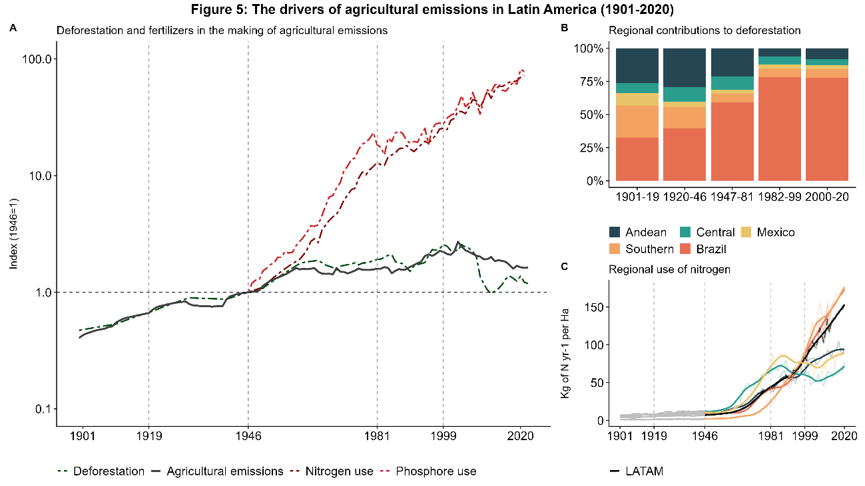
Figure 5.4: The drivers of agricultural emissions in Latin America (1901-2020)
Note: Regional nitrogen use per hectare (Panel C) before 1946 is shown in grey for illustrative purposes only, as these values are based on projections using global average rates of use. Source: our own data; see Section 2 for details.
Over the long term, deforestation experienced two major growth episodes: the first during the First Globalization (1901–1919) and the second during the ISI period (1947–1981), with average annual growth rates of 1.9% and 1.8%, respectively. Regionally, these waves were especially intense in Brazil, as well as in Central America and the Andes during the early period. During the ISI, however, Brazil emerged as the main driver of regional deforestation. Its annual growth rate reached 4.5% between 1946 and 1981, while rates in other regions were negative (see Table 5.A.2). As shown in Figure 5.4 Panel B, Brazil’s share of Latin American deforestation exceeded 50% during ISI and rose to 75% thereafter. At the beginning of the century, however, deforestation was more evenly distributed, with the Andean and Southern Cone regions each contributing around a quarter of total forest loss.
The use of nitrogen and phosphorus in agriculture accelerated sharply after mid-century with the spread of synthetic fertilizers. Between 1947 and 2020, fertilizer use increased at an average annual rate of 5.9%, marking the consolidation of a more intensive production model, whereas levels before 1947 were probably much lower, consistent with global patterns observed for the first half of the 20th century (2.7% between 1901 and 1946). This shift sustained output while offsetting the relative decline of deforestation as a source of emissions; thus, since 2000, fertilizer use has played an increasingly important role in shaping agricultural emissions.
While intensification raised productivity, it also reduced nutrient-use efficiency (as we will see) and generated risks of soil and water pollution. Indeed, agricultural intensification, and in particular the increase in N and P rates, have multiplied the loss of these nutrients to the environment, and their associated impacts (Billen et al., 2013; Sandström et al., 2023). Unlike the expansive pathway –whose impacts such as deforestation are widespread but less visible– intensification produces more localized degradation, especially in soils, air and water quality in the immediate environment of farming communities (Erisman et al., 2013; Guignard et al., 2017).
The regional pattern of fertilizer use evolved unevenly (Figure 5.4 Panel C). Central America, Mexico, and the Andean region displayed higher nitrogen use per hectare than the regional average by the 1950s, but Brazil’s later catch-up reshaped the pattern. By the end of ISI, the regional average had increased from 7 kg N ha⁻¹ yr⁻¹ in 1947 to 45 kg N ha⁻¹ yr⁻¹ in 1981. Mexico and Central America reached around 70 kg N ha⁻¹ yr⁻¹. After the debt crisis, nitrogen use accelerated in Brazil, Argentina, and, to a lesser extent, the Andes. By 2020, Brazil and Argentina had become regional leaders, each reaching roughly 170 kg N ha⁻¹ yr⁻¹ –double the Latin American average– while Mexico, Central America, and the Andes remained near 85 kg N ha⁻¹ yr⁻¹.
This trajectory underscores clear differences in timing and geography. Mexico and Central America were early adopters of fertilizer-based intensification, while Brazil and Argentina, as latecomers, ultimately became the main regional drivers. The long-term shift from land expansion to input intensification thus reveals how the drivers of agrarian change evolved over time and across regions, paving the way for an agricultural model increasingly defined by its environmental impacts. Building on this, the next subsection examines agricultural emissions, focusing on their regional dynamics and global significance.
4.2 Agricultural Emissions in Latin America: Regional Dynamics and Global Significance
Within the broader discussion of global emissions, agricultural activities occupy a central place in Latin America. When cumulative greenhouse gas (GHG) emissions per capita are considered, the region reaches levels comparable to those of Western Europe, largely due to emissions from land-use change (IPCC,2023 ).
Figure 5.5 Panel A shows that agricultural emissions have accounted for more than 70 % of cumulative emissions in Latin America since the mid-19th century. Among these, those generated by land-use change (LUC), primarily from deforestation, stand out, representing more than half of total cumulative emissions. Annual LUC emissions remained higher than those from other sources –mainly fossil fuels– between 1850 and 2005, peaking at 3 Gt CO₂eq in 2003 (Figure 5.5 Panel B). Afterward, fossil-fuel emissions surpassed LUC, but other agricultural sources related to intensification continued to grow.
Three main phases can be distinguished. First, from the late 19th century through the Great Depression, LUC emissions increased from 0.2 Gt CO₂eq in 1870 to 1 Gt in 1930, accounting for about 75% of total regional emissions. Second, during the ISI (1946–1981), they rose further to 1.6 Gt CO₂eq, but their relative share declined to 47% as industrialization increased fossil-fuel and non-CO₂ agricultural emissions, mainly methane (CH₄) and nitrous oxide (N₂O) from livestock and fertilizer use. Third, after 1985, another wave of LUC emissions occurred: between 1985 and 2022 they averaged 2 Gt CO₂eq per year, but their share fell to 28% by 2022 as other agricultural sources reached 1 Gt CO₂eq and 22% of total emissions. Agriculture therefore remains a leading source of CO₂-equivalent emissions in the region.
The carbon-rich character of Latin America’s forests amplifies the scale of emissions. Regionally, Figure 5.5 Panel C shows that at least half of cumulative emissions from deforestation and land-use change between 1850 and 2010 originated in Brazil, underscoring its central role in shaping the region’s extensive growth model. Brazil also accounts for more than half of the region’s nitrogen and phosphorus consumption, reflecting the parallel advance of intensification. Although smaller in absolute terms, the Andean and Central American regions contributed about 20 % of total emissions, illustrating how long-term extensification under tropical-forest conditions generates high per-hectare emissions.
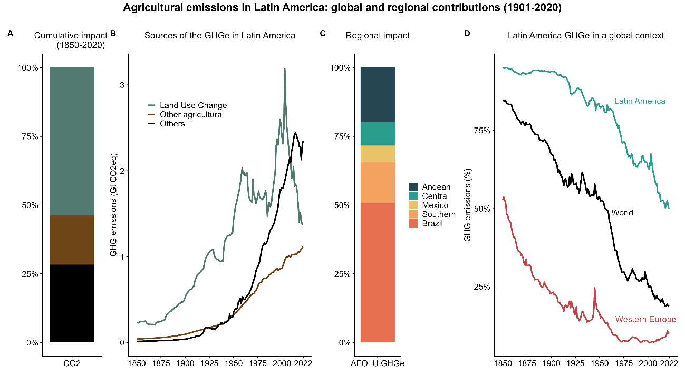
Figure 5.5: Agricultural emission in Latin America: regional and global contributions
Source: our own data, see section 2 for details.
This weight of agricultural emissions is particularly striking in global perspective. While fossil fuels have dominated most regions, in Latin America deforestation and related agrarian processes remained the main sources of GHGs well into the 21st century. The relative importance of agricultural emissions is much higher than the global average and far greater than in regions such as Western Europe, where forests are less extensive and carbon-dense and fossil-fuel use historically higher (Figure 5.5 Panel D).
Why does Latin American land-use change weigh so heavily in regional and global emissions? We argue that this does not necessarily imply that agrarian practices in the region are intrinsically dirtier than elsewhere. Rather, their higher relative weight reflects both timing and environmental context. That is temporal penalty and an environmental penalty.
The temporal penalty arises because regions that retained a high share of forest cover prior to trade integration in the late 19th century –such as Latin America and Southeast Asia– show higher cumulative agricultural emissions (1850–2020) than areas that converted forests earlier, like Europe (Figure 5.6 Panel A). This is also true for regions with low forest endowment (e.g., the Middle East, Central Asia, or North Africa) which refers to the environmental penalty, but let’s illustrate this at regional level in Latin America. The environmental penalty refers to forest quality; so, countries with carbon-dense forests such as rainforest in Brazil, much of Central America, Ecuador, and Colombia, emit far more per hectare than those dominated by temperate forests and landscapes such as the Pampas and the Chaco, where pastures and scrubland predominate and carbon density is comparatively lower (Figure 5.6 Panel B).
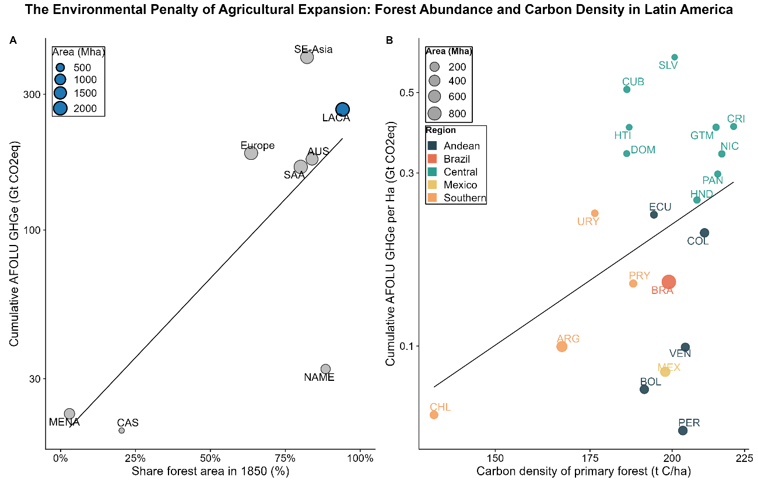
Figure 5.6: Timing and environmental penalties of agricultural expansion: forest abundance and carbon density in Latin America
Note: AUS: Australia; CAS: Central Asia; LACA: Latin America and the Caribbean; MENA: Middle East and North Africa; NAME: North America; SAA: South Asia; SE-Asia: Southeast Asia. Source: our own data, see section 2 for details.
Hence, both the timing of forest conversion and the biophysical characteristics of forests shape the long-term environmental impact of agrarian expansion. Deforestation during the First Globalization and ISI periods was most intense in Brazil and tropical Andean and Central American countries. Producing a hectare of wheat or a kilogram of meat in these settings releases much higher emissions than in temperate regions. This outcome stems less from irresponsible management than from the region’s ecological endowment and historical trajectory, which structurally amplify the environmental costs of production.
Until the mid-20th century, deforestation and land-use change were the dominant sources of GHG emissions in Latin America. Since the 1980s, emissions linked to intensification –articularly CH₄ and N₂O– have gained importance. While Brazil remains the largest absolute contributor, Andean and Central American countries have grown in relative weight due to their heavy reliance on synthetic fertilizers. The delayed onset of deforestation, combined with the high carbon density of tropical forests, explains both Latin America’s enduring global significance and its marked regional variations in environmental impact.
4.3 Have Environmental Impacts Declined with Intensification?
The literature analysing the relationship between environmental impacts and economic growth, or agricultural growth in our case, often revolves around two competing theories. The first is the Environmental Kuznets Curve (EKC) hypothesis, which offers an optimistic view. Following Simon Kuznets’s model of economic growth and inequality, it proposes that in the early stages of development activity becomes more polluting as impacts increase, while beyond a certain threshold it becomes cleaner, as efficiency gains and environmental awareness grow with income. Applied to agriculture, this would mean that as output increases and production systems move from extensive practices to more efficient intensive ones, impacts per unit of output decline.
The second theory, Jevons’s paradox, or the rebound effect, is more pessimistic. It suggests that efficiency improvements, such as lower emissions per unit of output, generate cost savings that, in turn, stimulate higher overall activity. These rebounds offset the efficiency gains, preventing absolute reductions in impacts. Efficiency improves, but total environmental pressure does not fall. Therefore, while relative decoupling between agricultural growth and environmental degradation may occur, absolute decoupling does not.
Testing these hypotheses in agriculture requires an analysis that exceeds the scope of this chapter. However, by comparing the trajectories of impacts and output, we can assess whether the historical relationship in Latin America reflects relative or absolute decoupling and the extent to which the pattern varies across indicators.
Figure 5.7 displays the evolution of environmental intensity for the four indicators analysed (red dashed line) alongside absolute impacts (blue area), while the straight black line signals the intensity index base line equal to 1 in 1901 for land emission and deforestation, and to 1946 for nitrogen and phosphorus. For biogeochemical flows (nitrogen and phosphorus), intensity increased continuously (Figures 5.7 Panels A and C). Until the mid-20th century, growth in intensity was modest, meaning that impacts rose roughly in line with output. After the 1950s, intensity accelerated sharply: more fertilizers were used per unit of production.
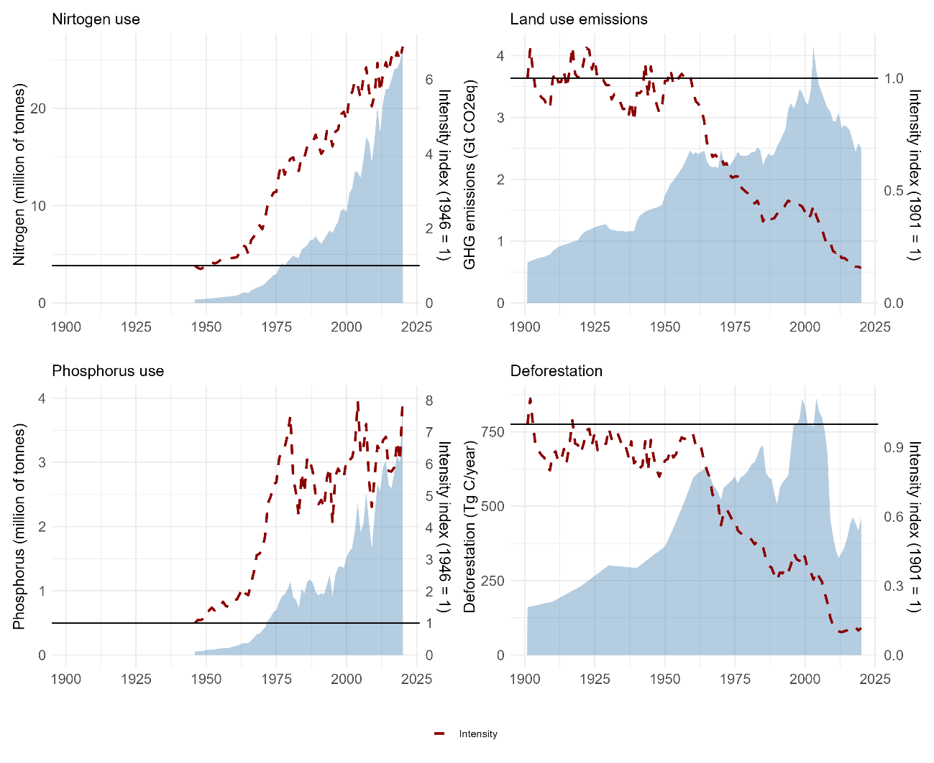
Figure 5.7 Absolute and relative growth of environmental impacts in Latin America
Note: The left axis shows absolute figures, while the right axis represents the intensity index. Source: our own data; see Section 2 for details.
This pattern, common in other world regions, stemmed from the rapid diffusion of chemical inputs, which were often applied inefficiently. Although agricultural productivity rose (Section 1), efficiency in nutrient use declined. Since 1975, intensity growth has stabilised –especially for phosphorus– but has not yet decreased. Thus, biogeochemical indicators of agricultural intensification show neither gains in efficiency nor reductions in absolute impacts. There is no rebound effect and no decoupling pattern from fertilizers because efficiency gains have not even begun.
For emissions and deforestation (Figures 5.7 Panels B and D), the trend diverges. Both show a long-term decline in intensity: since the mid-20th century, their growth has lagged behind output, reflecting slower expansion of the agricultural frontier and a greater role of intensification. Nonetheless, rebound effects are evident –for emissions in the 1980s–2000s and for forests at several moments, notably the 1970s–80s, 1990s–2000s, and since the 2010s. As a result, the region has not yet entered a true forest transition, in which net deforestation reverses and forest area recovers, as seen in some high-income countries.
This divergent pattern between extensive and intensive impacts reinforces the idea of a structural transition from land-expansive to input-dependent agriculture. The gradual reduction of intensity in land-use impacts, alongside rising nutrient and energy inputs, underscores a dominant growth model that remains high-impact and low-efficiency.
In short, while technological progress has improved yields and limited the land needed for expansion, it has not reduced total environmental pressure. Some indicators such as land-use emissions and deforestation benefit from relative efficiency gains, but nitrogen and phosphorus use require explicit policy and technological action to achieve absolute reductions. Understanding these dynamics is crucial for designing future environmental strategies that move beyond efficiency gains toward genuine sustainability.
- FROM FRONTIER EXPANSION TO AGRO-EXPORT INTENSIFICATION: AN ENVIRONMENTAL HISTORY OF LATIN AMERICAN AGRICULTURE
The long-term evidence presented in the previous sections shows that agrarian growth in Latin America has followed a shifting balance between expansion over land and intensification through technology and inputs. The resulting environmental pressures evolved accordingly: from deforestation and land-use change in the early 20th century to fertilizer- and energy-related emissions in recent decades. This section therefore interprets these results historically, using representative regional examples to trace how development models shaped agrarian structures and ecological outcomes.
5.1 Expansion and Environmental Costs during the First Globalization (1900–1930s)
The First Globalization (1850–1913) triggered deep transformations in Latin American agrarian systems. Integration into international markets consolidated liberal states and defined their agricultural trajectories for the 20th century. Except in countries like Bolivia, Chile, or Mexico
–where minerals dominated exports– most nations relied on crop and livestock commodities: maize, wheat, wool, and beef in the Southern Cone; coffee, rubber, bananas, tobacco, cacao, and sugar in the Andes, Central America, and the Caribbean (Bulmer-Thomas,2003 : Table 3.2).
In a context of abundant land but scarce labour, concentration served to restrict access and secure control over the workforce. Liberal governments promoted agro-export growth through infrastructure investment, tax exemptions, and export incentives, while redistributing land through legal reforms. In El Salvador, Guatemala, Colombia, Ecuador, and Mexico, desamortización laws expropriated Indigenous and Church lands, while in the Southern Cone military campaigns guaranteed the frontier expansion. In both cases, liberal states laid the groundwork for land concentration and the consolidation of agro-export economies, thereby facilitating agricultural expansion and deforestation (Martín-Retortillo et al., 2026).
Paradigmatic cases of frontier expansion can be found in Argentina and the Greater Caribbean. In Argentina, the expansion of La Pampa was financed through the sale of government bonds, while domestic and foreign investors, primarily British, supported military campaigns that seized Indigenous lands during the so-called Conquest of the Desert (1879–1885), reinforcing land concentration. In 1885 alone, nine million hectares were distributed among only 358 recipients in Buenos Aires, Córdoba, and La Pampa (Nagy, 2022), establishing the export-oriented beef and cereal system for the British market (Bulmer-Thomas, 2003; Martirén & Rayes, 2026).
The second striking example of how “La civilization” advanced over nature was in tropical forests with the case of the banana plantations established by the United Fruit Company (UFC) in the Greater Caribbean: Guatemala, Honduras, Costa Rica, Panama, Jamaica, and northern Colombia (Colmenares, 2024 ; Montero, 2024 ). Through concessions in exchange for railway construction and by acquiring or expropriating peasant lands, the UFC amassed over 1.2 million hectares by 1939, yet cultivated barely 5-10% (Colmenares,2024 ). The rest served as reserve land –an ecological and labour-control device. When soil fertility declined or diseases like Panama disease and Sigatoka spread, plantations were abandoned and new forests cleared. A form of “shifting cultivation” on a corporate scale (Colmenares, 2024) captured by García Márquez:
“La región encantada que exploró José Arcadio Buendía en los tiempos de la fundación, y donde luego prosperaron las plantaciones de banano, era un tremedal de cepas putrefactas, en cuyo horizonte remoto se alcanzó a ver por varios años la espuma silenciosa del mar” (García Márquez,1967 : 136).
This shared yet differentiated history of land expansion under liberal states –spanning both tropical and temperate agricultures– is clearly reflected in the dynamics of land-use change and deforestation emissions. While tropical countries saw high emissions with only modest increases in cropland, the Southern Cone experienced substantial cropland expansion with comparatively lower emissions rates (see Sections 3 and 4).
5.2 Extensification and Intensification under the ISI (1940s–1980s)
As seen, between the 1940s and 1980s, agricultural growth combined two intertwined dynamics: land expansion and intensification. The ISI period saw the largest wave of agrarian settlement of the century: nearly half of all land transferred between 1900 and 2000 occurred then, with colonization accounting for over a third. Brazil led in absolute terms (49% of all colonized land), followed by Mexico, Colombia, Peru, Venezuela, and Bolivia (see chapters in Volume II). Beyond its political ends (Albertus, 2015, ; LeGrand,1986 ), colonization programs integrated frontier zones and cropland expanded markedly in Brazil, the Andes, and Mexico illustrating the footprint of ISI policies on forest loss (Section 4.1).
Parallel to expansion, governments promoted agricultural modernization as part of broader state-led industrialization. Agriculture was to supply food for urban populations, inputs for industries, and foreign exchange (Bulmer-Thomas,2003 ; Cárdenas et al., 2000). Public investment, technical assistance, and research centres spread improved seeds, fertilizers, mechanization, and irrigation, though unevenly (Cárdenas et al., 2000). Livestock, especially poultry, underwent quasi-industrial transformations (Bértola & Ocampo, 2012). Yields rose by 50% in crops and 30% in livestock between 1960 and 1980, while capital and total-factor-productivity gains reinforced modernization (Martín-Retortillo et al., 2026).
Trade policy also shaped production. Export taxes, currency overvaluation, and protectionism penalized traditional export crops like coffee or sugar (Bértola &), but fostered import-substitution in food staples. Under the International Coffee Agreement, however, regulated exports and domestic substitution coexisted consistent with increased land devoted to coffee and wheat in Mexico (Tortolero & Mendez, 2026), Colombia (Colmenares & Vivas, 2026), and Central America and wheat and sugar in Brazil (Klein & Vidal Vivas, 2026) as seen in Section 3.2.
Frontier settlement sustained deforestation, while technological change generated new emission sources marking a qualitative shift in the region’s agrarian metabolism (Section 4.3). By the late 1970s, these intensive sources began to rival land-use emissions, reflecting a structural transition in agrarian impacts. After a decade of cheap credit and mounting debt, falling commodity prices and rising interest rates created an adverse context in which the burden of external debt ultimately overwhelmed Latin American countries. Several rounds of debt restructuring, fiscal adjustment, and export promotion gradually consolidated as the main strategy to ensure debt repayment, displacing the ISI model.
5.3 Return to Markets: Specialization and New Environmental Impacts (1980–2020)
The 1982 Mexican default exposed structural weaknesses accumulated during ISI. As external debt soared –tripling between 1975 and 1980 (Ocampo et al., 2014: Table 2)– Latin American countries turned to structural adjustment and export promotion. Reforms encouraged trade liberalization and market-oriented agriculture to restore foreign exchange. Liberalization, however, did not significantly stimulate agricultural growth, which was lower in the 1980s than in the 1970s (Weeks, 1995 ).
Moreover, land endowments and institutions determined distinct strategies of integration. In the Andes, Mexico, and Central America –where land scarcity prevailed– growth relied on intensification and specialization in high-energy crops such as oil palm, bananas, sugarcane, and pineapples. In contrast, Brazil and the Southern Cone, endowed with abundant land, pursued a mixed strategy combining new cropland and technological intensification, particularly through soybean expansion.
Institutional paths toward export agriculture were uneven, but state action –liberalized trade, agribusiness legislation, and infrastructure investment– was crucial (Norberg, 2019 ). In Costa Rica, stronger governance enabled a smoother, market-based transition, while in Guatemala, El Salvador, and Colombia, civil wars rooted in land inequality shaped agrarian restructuring. In Colombia, violence and displacement reinforced agro-export consolidation, particularly in bananas and oil palm (Grajales, 2021 ; Maher, 2015; Urrego-Mesa,2021 ), illustrating how conflict and markets jointly produced new agrarian geographies. Thus, state participation, market incentives and conflicts over redistribution of the new model shaped the way of the transition towards agro-export intensification of land.
In the Southern Cone, soy symbolised the shift toward capital-intensive, export-oriented agriculture characteristic of the third food regime (McMichael, 2013 ; Norberg, 2019 ). Its early expansion in Brazil and Paraguay occurred under authoritarian developmentalism: Brazil’s dictatorship (1964–1985) promoted agricultural exports to earn foreign currency, while Paraguay’s regime (1954–1989) encouraged land concentration and settlement by Brazilian farmers. Liberalization in the 1980s–1990s accelerated this process through land titling, Genetically Modified Organism deregulation, and forest conversion, transforming traditional crop-livestock rotations in the Pampas into soy monocultures and driving deforestation in the Gran Chaco, the Atlantic Forest and the Amazon. Across the region, input use and land concentration intensified, deepening environmental degradation.
China’s entry into the World Trade Organization in 2000 inaugurated a new expansionary cycle. Rising commodity prices and lower interest rates brought an end to two decades of macroeconomic constraints (Bértola & Ocampo, 2012). Between 2000 and 2020, Latin American agricultural output more than doubled through both expansion and intensification, consolidating earlier strategies.
This phase also redefined the state’s role, characterized by a shared aim of reducing the social costs of natural resource exploitation by increasing the redistributive capacity of the state. Governments combined market orientation with selective activism: Argentina’s soy export taxes, Paraguay’s Payment for Ecosystem Services, and Uruguay’s public investment with environmental regulation (Norberg, 2019). Scholars have described this hybrid pattern as neo-extractivism, or agrarian extractivism in this case, a regime blending renewed commodity specialization with social compensation (Gudynas,2009 ; McKay et al, 2021; Veltmeyer & Pertras, 2014).
Beyond the definition, the environmental effects have been significant. Brazil saw a new deforestation peak (2003–2006), while fertilizer-related emissions surpassed those from land-use change. Despite lower deforestation intensity, total emissions remained high, and no efficiency gains in fertilizer use were achieved (Section 4). Agricultural growth thus shifted its environmental burden rather than reduced it. The promise of modernization came with a heavier and more persistent ecological pressure –marking a new stage in the region’s environmental history.
- CONCLUSIONS
This chapter has examined the long-term trajectory of agricultural growth in Latin America and the strategies employed over the 20th and early 21st centuries to achieve it, while also addressing their environmental consequences. It has focused on two guiding questions: to what extent has agricultural growth in Latin America relied on land expansion and/or intensification, and what have been the environmental consequences of these strategies, particularly in terms of deforestation, greenhouse gas emissions, and biogeochemical disruption?
The empirical analysis has identified three major phases of agrarian growth. During the First Globalization (1901–1919), growth was largely achieved through extensification –expanding cultivated area, particularly in the Southern Cone and Caribbean, often at the expense of forested land. The state-led development period (1947-1981) introduced a new dual logic: continued frontier expansion through colonization and land reform –especially in Brazil, Mexico, and Colombia– combined with the modernization of agriculture via technological change and favourable agricultural and trade policies. After the return to global markets in the 1980s, and particularly during the commodity boom of the early 2000s, growth became increasingly shaped by agro-export specialization and input-driven intensification. While Central America and the Andes relied mainly on high-energy tropical crops, the Southern Cone and Brazil pursued mixed strategies combining expansion and capital-intensive production, notably soybeans. Despite these differences, the long-term pattern of crop and geographical concentration remained a defining feature of Latin American agriculture.
These changing growth strategies translated into evolving environmental impacts. Early deforestation was geographically widespread but most pronounced in Brazil, the Andes, and Central America, while the Southern Cone experienced lower relative impacts. During the ISI period, state-led colonization reinforced deforestation through the settlement of frontier lands, even as technological modernization increased land productivity. In this context, Brazil became the dominant driver of regional deforestation, while modernization marked a turning point in the surge of intensive impacts. Since the 2000s, deforestation has slowed, yet emissions linked to intensification, particularly nitrous oxide (N₂O) from fertilizers and methane (CH₄) from livestock, have accelerated. By 2020, land-use change and other agricultural emissions accounted for more than half of the region’s total greenhouse gas emissions, positioning agriculture as a central driver of the region’s contribution to climate change.
Over the long term, Latin American agriculture has evolved from extensive land conversion to a model of input-dependent, export-oriented production. This trajectory reveals a persistent structural pattern: increasing output and environmental pressures sustained by the active role of the state in securing agricultural growth within changing models of development. While the instruments and objectives have shifted –from frontier colonization to export promotion– the underlying extractive logic has endured, linking agricultural growth to the depletion of natural resources and the deepening of global market dependence.
- REFERENCES
Albertus, M. (2015), Autocracy and redistribution, Cambridge University Press.
Andrew, R. M. & Peters, G. P. (2021), ‘The Global Carbon Project’s fossil CO₂ emissions dataset’, Zenodo. https://zenodo.org/records/5569235
Ang, B. W. (2005), ‘The LMDI approach to decomposition analysis: a practical guide’, Energy Policy 33(7), 867–871.
Bértola, L. & Ocampo, J. A. (2012), The economic development of Latin America since independence, OUP Oxford.
Billen, G., Garnier, J. & Lassaletta, L. (2013), ‘The nitrogen cascade from agricultural soils to the sea: modelling nitrogen transfers at regional watershed and global scales’, Philosophical Transactions of the Royal Society B: Biological Sciences 368(1621), 20130123.
Bulmer-Thomas, V. (2003), The economic history of Latin America since independence, Cambridge University Press.
Campbell, B. M., Beare, D. J., Bennett, E. M., Hall-Spencer, J. M., Ingram, J. S. I., Jaramillo, F., Ortiz, R., Ramankutty, N., Sayer, J. A. & Shindell, D. (2017), ‘Agriculture production as a major driver of the Earth system exceeding planetary boundaries’, Ecology and Society 22(4).
Cárdenas, E., Ocampo, J. & Thorp, R. (2000), An Economic History of Twentieth-Century Latin America: Industrialization and the State in Latin America: The Postwar Years, Vol. 3, Springer.
Colmenares, S. (2024), ‘“The best lands have been taken”: el proceso de acumulación de tierras de la United Fruit Company a lo largo de la frontera del banano en el Gran Caribe, 1900–1940’, Historia Agraria de América Latina 5(02), 29–55.
Colmenares, S., & Vivas, J. (2026). Policies and performance of Colombia's agriculture and livestock sector over the last 150 years. In M. Martín-Retortillo et al. (Eds.), 150 years of Latin American agricultures (Vol. 2). Palgrave Macmillan.
Domínguez, J. I. & Mares, D. R. (2003), Boundary Disputes in Latin America, United States Institute of Peace.
Federico, G. (2010). Feeding the world: an economic history of agriculture, 1800-2000. Princeton University Press.
Erisman, J. W., Galloway, J. N., Seitzinger, S., Bleeker, A., Dise, N. B., Petrescu, A. R., Leach, A. M. & de Vries, W. (2013), ‘Consequences of human modification of the global nitrogen cycle’, Philosophical Transactions of the Royal Society B: Biological Sciences 368(1621), 20130116.
FAOSTAT (2025), ‘Food and agriculture database’. http://www.fao.org/faostat/en/
Friedlingstein, P., Jones, M. W., O’Sullivan, M., Andrew, R. M., Bakker, D. C., Hauck, J., Le Quéré, C., Peters, G. P., Peters, W., Pongratz, J. et al. (2022), ‘Global carbon budget 2021’, Earth System Science Data 14(4), 1917–2005.
Funes Monzote, R. (2008), From rainforest to cane field in Cuba: an environmental history since 1492, University of North Carolina Press.
García Márquez, G. (1967), Cien años de soledad. https://online.anyflip.com/dilbv/ohlf/mobile/
Gasser, T., Crepin, L., Quilcaille, Y., Houghton, R. A., Ciais, P. & Obersteiner, M. (2020), ‘Historical CO₂ emissions from land use and land cover change and their uncertainty’, Biogeosciences 17(15), 4075–4101.
Grajales, J. (2021), Agrarian Capitalism, War and Peace in Colombia: Beyond Dispossession, Routledge, London.
Gudynas, E. (2009), ‘Diez tesis urgentes sobre el nuevo extractivismo’, Extractivismo, política y sociedad, 187-225.
Guignard, M. S., Leitch, A. R., Acquisti, C., Eizaguirre, C., Elser, J. J., Hessen, D. O., Jeyasingh, P. D., Neiman, M., Richardson, A. E., Soltis, P. S. et al. (2017), ‘Impacts of nitrogen and phosphorus: from genomes to natural ecosystems and agriculture’, Frontiers in Ecology and Evolution 5, 70.
Gütschow, J., Jeffery, M. L., Gieseke, R., Gebel, R., Stevens, D., Krapp, M. & Rocha, M. (2016), ‘The PRIMAP-hist national historical emissions time series’, Earth System Science Data 8(2), 571–603.
Guzmán, G. & González de Molina, M. (2017), Energy in Agroecosystems. A Tool for Assessing Sustainability, CRC Press: Boca Raton, FL, USA.
Hansis, E., Davis, S. J. & Pongratz, J. (2015), ‘Relevance of methodological choices for accounting of land use change carbon fluxes’, Global Biogeochemical Cycles 29(8), 1230–1246.
Hong, C., Zhao, H., Qin, Y., Burney, J. A., Pongratz, J., Hartung, K., Liu, Y., Moore, F. C., Jackson, R. B., Zhang, Q. et al. (2022), ‘Land-use emissions embodied in international trade’, Science 376(6593), 597–603.
Houghton, R. A. & Nassikas, A. A. (2017), ‘Global and regional fluxes of carbon from land use and land cover change 1850–2015’, Global Biogeochemical Cycles 31(3), 456–472.
Hurtt, G. C., Chini, L., Sahajpal, R., Frolking, S., Bodirsky, B. L., Calvin, K., Doelman, J. C., Fisk, J., Fujimori, S., Klein Goldewijk, K. et al. (2020), ‘Harmonization of global land use change and management for the period 850–2100 (LUH2) for CMIP6’, Geoscientific Model Development 13(11), 5425–5464.
Infante-Amate, J. & Picado, W. (2018), ‘Energy flows in the coffee plantations of Costa Rica: from traditional to modern systems (1935–2010)’, Regional Environmental Change 18(4), 1059–1071.
Infante-Amate, J., Travieso, E. & Aguilera, E. (2025), ‘The history of a +3° C future: Global and regional drivers of greenhouse gas emissions (1820–2050)’, Global Environmental Change 92, 103009.
Infante-Amate, J., Urrego-Mesa, A., Piñero, P. & Tello, E. (2022), ‘The open veins of Latin America: Long-term physical trade flows (1900–2016)’, Global Environmental Change 76, 102579.
IPCC (2021), Climate Change 2021: The Physical Science Basis. Contribution of Working Group I to the Sixth Assessment Report of the Intergovernmental Panel on Climate Change, Cambridge University Press, Cambridge, United Kingdom and New York, NY, USA.
IPCC (2022), Climate Change 2022: Mitigation of Climate Change. Contribution of Working Group III to the Sixth Assessment Report of the Intergovernmental Panel on Climate Change, Cambridge University Press, Cambridge, UK and New York, NY, USA.
IPCC (2023), ‘Climate change 2023: Synthesis report. Contribution of Working Groups I, II and III to the Sixth Assessment Report of the Intergovernmental Panel on Climate Change’.
Jones, M. W., Peters, G. P., Gasser, T., Andrew, R. M., Schwingshackl, C., Gütschow, J., Houghton, R. A., Friedlingstein, P., Pongratz, J. & Le Quéré, C. (2023), ‘National contributions to climate change due to historical emissions of carbon dioxide, methane, and nitrous oxide since 1850’, Scientific Data 10(1), 155.
Kaltmeier, O., López Sandoval, M. F., Pádua, J. & Zarrilli, A. E. (2024), El Antropoceno como Crisis Múltiple: Perspectivas desde América Latina. Volumen 1: Uso de la Tierra, CLACSO–CALAS.
Kastner, T., Schaffartzik, A., Eisenmenger, N., Erb, K.-H., Haberl, H. & Krausmann, F. (2014), ‘Cropland area embodied in international trade: Contradictory results from different approaches’, Ecological Economics 104, 140–144.
Klein, H., & Vidal Luna, F. (2026). The history of Brazilian agriculture from 1870 to 2020. In M. Martín-Retortillo et al. (Eds.), 150 years of Latin American agricultures (Vol. 2). Palgrave Macmillan.
LaRota-Aguilera, M. J., Delgadillo-Vargas, O. L. & Tello, E. (2022), ‘Sociometabolic research in Latin America: A review on advances and knowledge gaps in agroecological trends and rural perspectives’, Ecological Economics 193, 107310.
LeGrand, C. (1986), Frontier expansion and peasant protest in Colombia, 1850–1936, University of New Mexico Press.
Leigh, G. J. (2004), The world’s greatest fix: a history of nitrogen and agriculture, Oxford University Press.
Maher, D. (2015), ‘Rooted in violence: Civil war, international trade and the expansion of palm oil in Colombia’, New Political Economy 20(2), 299–330.
Martín-Retortillo, M., Pinilla, V., Velazco, J. & Willebald, H. (2026). Between domestic and international boosts and harms: The evolution of Argentine agrarian sector, 1870-2020. In M. Martín-Retortillo, V. Pinilla, J. Velazco & H. Willebald (Eds.), 150 years of Latin American agricultures: Persistence, evolution and change (1870-2020). Palgrave Macmillan.
McKay, B. M., Fradejas, A. A. & Ezquerro-Cañete, A. (2021), Agrarian Extractivism in Latin America, Routledge, London.
McMichael, P. (2013), Food regimes and agrarian questions, Fernwood Publishing.
Minx, J. C., Lamb, W. F., Andrew, R. M., Canadell, J. G., Crippa, M., Döbbeling, N., Forster, P. M., Guizzardi, D., Olivier, J., Peters, G. P. et al. (2021), ‘A comprehensive dataset for global, regional and national greenhouse gas emissions by sector 1970–2019’, Earth System Science Data Discussions 2021, 1–63.
Montero, A. (2024), ‘Entre la frontera nacional y transnacional: la expansión del banano en Costa Rica en el contexto de su comoditización (1899–1930)’, Historia Agraria de América Latina 5(02), 1–28.
Montero-Mora, A. & Goebel-Mc Dermott, A. (2023), ‘Socioecological transformations at the specialized productive space in coffee and sugarcane in the context of the Green Revolution. Costa Rica (1955–1973)’, Ecological Economics 208, 107790.
Nagy, M. (2022), ‘¿Cuántas y quiénes? La venta de las tierras de la conquista del desierto (1879–1885) en Buenos Aires, Córdoba y en el Territorio Nacional de La Pampa’, Diálogo Andino (68), 134–150.
Nash, M. H. (2022), ‘The 201 most (& least) biodiverse countries’. https://theswiftest.com/biodiversity-index/
Norberg, M. B. (2019), The Political Economy of Agrarian Change in Latin America: Argentina, Paraguay and Uruguay, Springer.
Ocampo, J. A., Stallings, B., Bustillo, I., Velloso, H. & Frenkel, R. (2014), La crisis latinoamericana de la deuda desde la perspectiva histórica, CEPAL.
Pendrill, F., Persson, U. M., Godar, J., Kastner, T., Moran, D., Schmidt, S. & Wood, R. (2019), ‘Agricultural and forestry trade drives large share of tropical deforestation emissions’, Global Environmental Change 56, 1–10.
Pengue, W. A. & Rodríguez, A. F. (2017), El vaciamiento de las Pampas: la exportación de nutrientes y el final del granero del mundo, Heinrich Böll Stiftung, Santiago de Chile.
Pinilla, V. & Aparicio, G. (2015), ‘Navigating in troubled waters: South American exports of food and agricultural products, 1900–1950’, Revista de Historia Económica / Journal of Iberian and Latin American Economic History 33(2), 223–255.
Richardson, K., Steffen, W., Lucht, W., Bendtsen, J., Cornell, S. E., Donges, J. F., Drüke, M., Fetzer, I., Bala, G., Von Bloh, W. et al. (2023), ‘Earth beyond six of nine planetary boundaries’, Science Advances 9(37), eadh2458.
Sandström, V., Kaseva, J., Porkka, M., Kuisma, M., Sakieh, Y. & Kahiluoto, H. (2023), ‘Disparate history of transgressing planetary boundaries for nutrients’, Global Environmental Change 78, 102628.
Soluri, J., Leal, C. & Pádua, J. A. (2018), ‘Finding the Latin American in Latin American environmental history’. In A Living Past: Environmental Histories of Modern Latin America. Berghahn, New York.
Steffen, W., Richardson, K., Rockström, J., Cornell, S. E., Fetzer, I., Bennett, E. M., Biggs, R., Carpenter, S. R., De Vries, W., De Wit, C. A. et al. (2015), ‘Planetary boundaries: Guiding human development on a changing planet’, Science 347(6223).
Tortolero, A., & Méndez, D. (2026). De la disputa por la tierra a los mercados globales. In M. Martín-Retortillo et al. (Eds.), 150 years of Latin American agricultures (Vol. 2). Palgrave Macmillan.
Urquijo Torres, P. S., Lazos Fuentes, A. E. & Lefebvre, K. (2022), Historia ambiental de América Latina: enfoques, procedimientos y cotidianidades, Universidad Nacional Autónoma de México.
Urrego-Mesa, A. (2021), ‘Food security, trade specialization, and violence in Colombia (1916–2016)’, Investigaciones de Historia Económica / Economic History Research. 17(4), 1–15.
Urrego-Mesa, A., Infante-Amate, J. & Tello, E. (2025), ‘The shadow of tropical agriculture: Energy transition of Colombian trade-driven agriculture in the 20th century’, Ecological Economics 231, 108541.
Veltmeyer, H. & Petras, J., eds (2014), The New Extractivism: A Post-Neoliberal Development Model or Imperialism of the Twenty-First Century?, Zed Books Ltd.
Weeks, J. (1995), Structural adjustment and the agricultural sector in Latin America and the Caribbean, Springer.

- APPENDIX
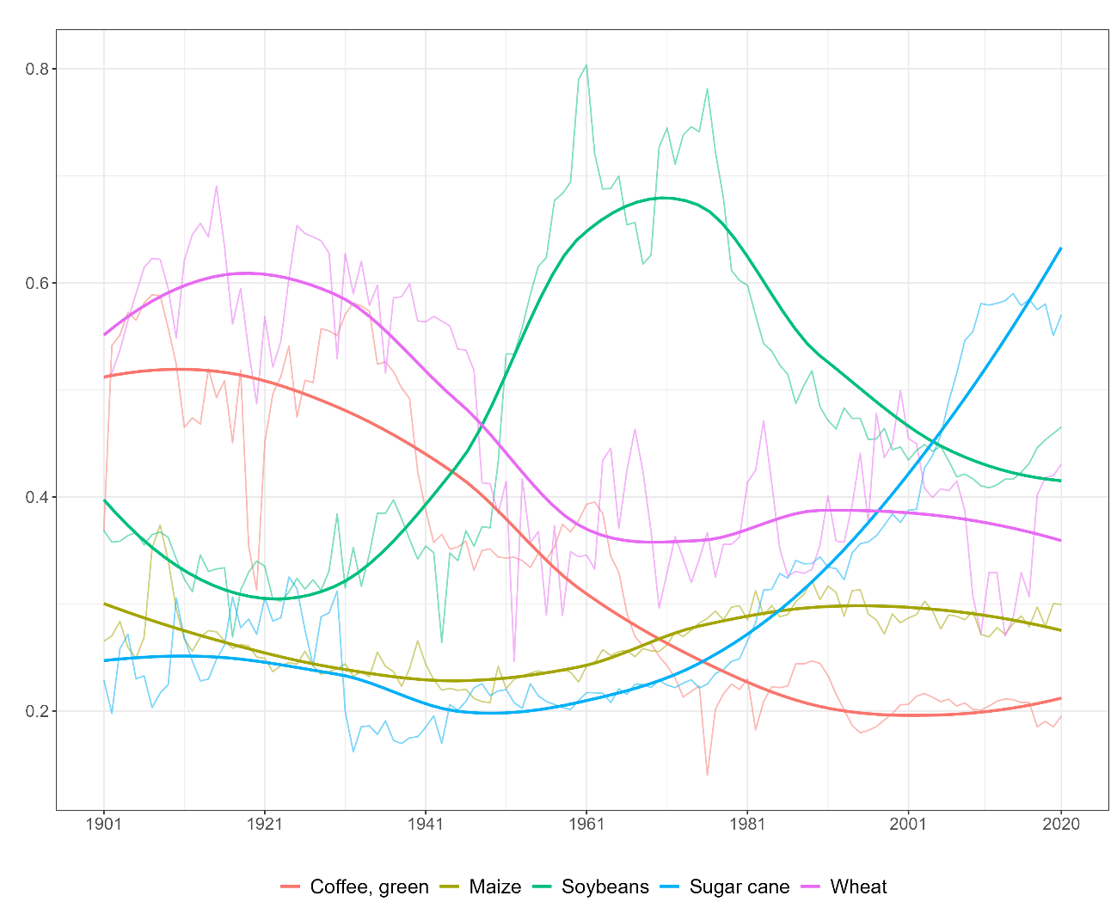
Figure 5.A.1: HHI of geographic concentration of Latin American harvested area (1901-2020)

Table 5.A 1: Land and population in the sample countries and percentage in 2020
ISO3 | Area | Land (ha)* | % of area | Population* | % of population |  | Region
BRA | Brazil | 835,814 | 41.7% | 212,559.417 | 32.6% | Brazil
ARG | Argentina | 273,669 | 13.7% | 45,195.774 | 6.9% | Southern
MEX | Mexico | 194,395 | 9.7% | 128,932.753 | 19.8% | Mexico
PER | Peru | 128,000 | 6.4% | 32,971.854 | 5.1% | Andean
COL | Colombia | 110,950 | 5.5% | 50,882.891 | 7.8% | Andean
BOL | Bolivia (Plurinational State of) | 108,330 | 5.4% | 11,673.021 | 1.8% | Andean
VEN | Venezuela (Bolivarian Republic of) | 88,205 | 4.4% | 28,435.940 | 4.4% | Andean
CHL | Chile | 74,353 | 3.7% | 19,116.201 | 2.9% | Southern
PRY | Paraguay | 39,730 | 2.0% | 7,132.538 | 1.1% | Southern
ECU | Ecuador | 24,836 | 1.2% | 17,643.054 | 2.7% | Andean
URY | Uruguay | 17,502 | 0.9% | 3,473.730 | 0.5% | Southern
NIC | Nicaragua | 12,034 | 0.6% | 6,624.554 | 1.0% | Central
HND | Honduras | 11,189 | 0.6% | 9,904.607 | 1.5% | Central
GTM | Guatemala | 10,716 | 0.5% | 17,915.568 | 2.7% | Central
CUB | Cuba | 10,380 | 0.5% | 11,326.616 | 1.7% | Central
PAN | Panama | 7,418 | 0.4% | 4,314.767 | 0.7% | Central
CRI | Costa Rica | 5,106 | 0.3% | 5,094.118 | 0.8% | Central
DOM | Dominican Republic | 4,831 | 0.2% | 10,847.910 | 1.7% | Central
HTI | Haiti | 2,756 | 0.1% | 11,402.528 | 1.7% | Central
SLV | El Salvador | 2,072 | 0.1% | 6,486.205 | 1.0% | Central
- | Others | 41,372 | 2.1% | 10,303.143 | 1.6% | -
Note: *thousands. Source: FAOSTAT (2025).

Table 5.A 2: Annual rates of growth for land emissions, deforestation, and nitrogen and phosphorus use in Latin America and by regions
Indicator | Region | 1st Gl. (1901-19) | Crisis (1920-46) | ISI (1947-81) | Crisis (1982-99) | 2nd Gl. (2000-20)
Land | LACA | 2.5 | 1.3 | 1.4 | 2.0 | -1.2
Deforestation |  | 1.9 | 1.5 | 1.9 | 1.7 | -3.3
Nitrogen |  | 2.7 | 2.7 | 7.7 | 4.3 | 5.2
Phosphorus |  | 1.8 | 3.1 | 8.4 | 2.7 | 4.5
Land | Andean | 2.7 | 1.7 | -0.6 | 2.7 | -1.5
 | Brazil | 4.3 | 1.0 | 3.3 | 2.3 | -1.4
 | Central | 2.1 | 3.8 | -0.2 | 0.8 | -3.1
 | Mexico | -2.7 | 3.9 | -0.5 | 0.0 | 1.8
 | Southern | 2.0 | -0.8 | 0.6 | 0.9 | -0.9
Deforestation | Andean | 1.9 | 2.2 | -2.6 | 4.2 | -3.1
 | Brazil | 4.1 | 0.7 | 4.5 | 1.2 | -3.5
 | Central | 2.8 | 3.9 | -0.9 | 2.3 | -6.0
 | Mexico | -1.5 | 1.3 | -1.2 | 0.9 | 3.6
 | Southern | -0.2 | 0.1 | -1.3 | 4.4 | -3.3
Nitrogen | Andean |  |  | 6.1 | 4.1 | 2.2
 | Brazil |  |  | 8.0 | 5.0 | 6.6
 | Central |  |  | 6.7 | 0.3 | 0.9
 | Mexico |  |  | 8.4 | 0.4 | -0.1
 | Southern |  |  | 8.2 | 9.1 | 6.0
Phosphorus | Andean |  |  | 5.2 | 2.2 | 1.6
 | Brazil |  |  | 9.6 | 2.9 | 5.1
 | Central |  |  | 6.3 | 0.9 | 0.3
 | Mexico |  |  | 9.4 | -1.7 | 3.4
 | Southern |  |  | 6.5 | 9.1 | 4.3

Table 5.A 3: International and national sources used before 1961
Category | Source | Description / Coverage
International sources | Institut International d’Agriculture (IIA), Annuaire international de statistique agricole, Rome | Various years 1910–1947 (data 1901–1945)
 | Food and Agriculture Organization of the United Nations (FAO), Yearbook of Food and Agricultural Statistics / Production Yearbook / Trade Yearbook, Rome | Various years 1949–1961 (data 1946–1960). FAO yearbooks compile international statistics on agricultural production, trade, and land use. (FAOHome)
 | FAOSTAT (2025), Food and Agriculture Database, FAO, Rome | Online statistical database covering agricultural production, land use, livestock, and trade for most countries worldwide. (FAOHome)
 | League of Nations, International Statistical Yearbook / Statistical Yearbook, Geneva | Various years 1926–1944
 | Mitchell, B. R. (1983), International Historical Statistics: The Americas and Australasia, Macmillan, London | Historical statistical compilation for countries in the Americas
 | United Nations, Statistical Yearbook, New York | Various years 1948–1962
National statistical sources | Argentina: Anuario estadístico de la República Argentina; Censos nacionales agropecuarios | Buenos Aires; various years: 1895, 1908, 1914, 1937
 | Bolivia: Comercio exterior de Bolivia | La Paz, various years: 1928–1952
 | Brazil: Anuário estatístico do Brasil | Rio de Janeiro/Brasília, various years: 1908–1961
 | Chile: Sinopsis estadística de Chile / Comercio exterior de Chile | Santiago, various years: 1926–1960
 | Colombia: Anuario de comercio exterior / Anuario general de estadística | Bogotá, various years 1916–1957
 | Costa Rica: Estadística de comercio exterior | San José, 1949
 | Cuba: Comercio exterior de la República de Cuba | Havana, various years: 1925–1958
 | Ecuador: Comercio exterior | Quito, 1925–1926
 | El Salvador: Anuario estadístico | San Salvador, various years: 1936–1952
 | Guatemala: Anuario de comercio exterior | Guatemala City, 1954
 | Mexico: Anuario estadístico de los Estados Unidos Mexicanos | Mexico City, various years: 1938–1961
 | Nicaragua: Anuario estadístico / Resumen estadístico | Managua, various years 1942–1960
 | Paraguay: Anuario estadístico del Paraguay | Asunción, various years 1914–1959
 | Peru: Extracto estadístico del Perú / Anuario estadístico del Perú | Lima, various years 1919–1957
 | Venezuela: Anuario estadístico de Venezuela | Caracas, various years 1912–1963
 | Uruguay: Anuario estadístico de la República Oriental del Uruguay | Montevideo, various years 1916–1943

Table 5.A 4: Data coverage by period, indicator, and region
Region | Period | Area | Production
LACA | 1901–1919 | 35 (57) | 32 (44)
 | 1920–1939 | 69 (78) | 68 (74)
 | 1940–1960 | 85 (86) | 79 (80)
Mexico | 1901–1919 | 51 (52) | 51 (51)
 | 1920–1939 | 87 (88) | 79 (77)
 | 1940–1960 | 97 (96) | 93 (93)
Central | 1901–1919 | 13 (13) | 55 (59)
 | 1920–1939 | 42 (44) | 69 (76)
 | 1940–1960 | 55 (56) | 70 (72)
Andean | 1901–1919 | 5 (4) | 9 (12)
 | 1920–1939 | 23 (25) | 21 (23)
 | 1940–1960 | 43 (43) | 38 (37)
Brazil | 1901–1919 | 14 (25) | 5 (7)
 | 1920–1939 | 73 (79) | 85 (84)
 | 1940–1960 | 96 (97) | 97 (97)
Southern | 1901–1919 | 77 (94) | 65 (81)
 | 1920–1939 | 83 (95) | 70 (84)
 | 1940–1960 | 94 (96) | 86 (88)
Note: Values shown as A (B), where A = Method A (share of 1961 total value represented by items with original data) and B = Method B (share of each year’s total volume from original data). Method A is conservative because the 1961 denominator includes products absent in earlier periods. All 20 Latin American countries are included. Values averaged over each period.

This research does not address the 19th century phase of export expansion. However, it does focus on the final stage of that process, which unfolded during the 20th century. According to V. Bulmer-Thomas, the period of greatest export expansion and a certain maturity of the export model occurred between approximately 1890 and 1912, a phase supported by the relative monetary stability that preceded the First World War (Bulmer-Thomas,2003 ). Therefore, we are able of capturing some of this expansion, but specially the end of the cycle. This methodological decision has been imposed by the availability of data.
For a review of the agrarian metabolism in Latin America, see LaRota (2022).)
In our sample Central America and the Caribbean include: Nicaragua, Honduras, Guatemala, Cuba, Panama, Costa Rica, Dominican Republic, Haiti and El Salvador.
The notation ha⁻¹ yr⁻¹ indicates “per hectare per year,” used to express flows measured relative to land area and time, commonly applied to variables such as fertilizer use or nutrient application rates.
To properly test the environmental penalty hypothesis, further research is needed. The LUH2 data used in this study account only for biomass carbon stocks, not for soil carbon stocks. In grassland landscapes such as the Pampas, soil carbon losses can be significant, as shown for the case of the Great Plains in the United States. This omission may lead to an overestimation of the environmental penalty in tropical forest regions.
There was, however, considerable variation. In Costa Rica, it remained around 15% until 1915, while in Panama it exceeded 50% up to 1908. By contrast, in other cases, such as Colombia or Guatemala after 1925, the entirety of available land was under cultivation (own calculations based on Colmenares, 2024: appendices 1 and 2).
We use the LUH2 cropland dataset (Hurtt et al., 2020) and our own harvested-area series to estimate the amount of transferred land, which ranges between 96 and 104 Mha. The extensification trends identified in our series during the ISI period are consistent with the large-scale land transfers documented by Albertus (2015:131).

